**Features of Container Orchestration Engine**

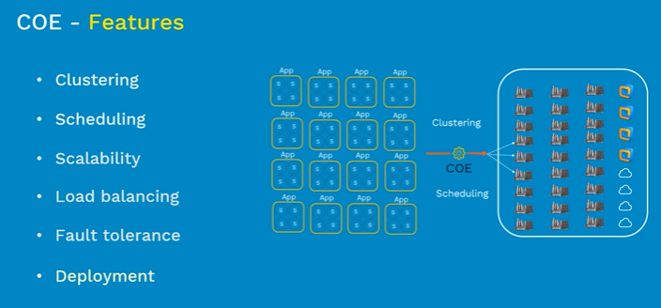

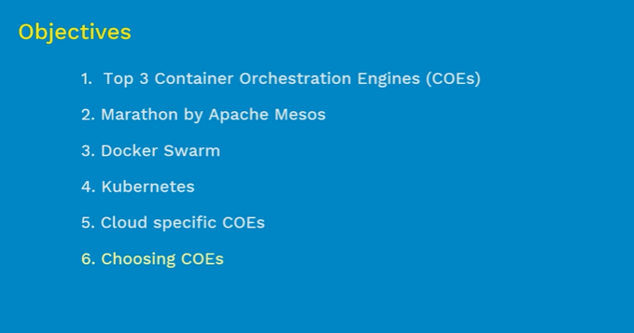

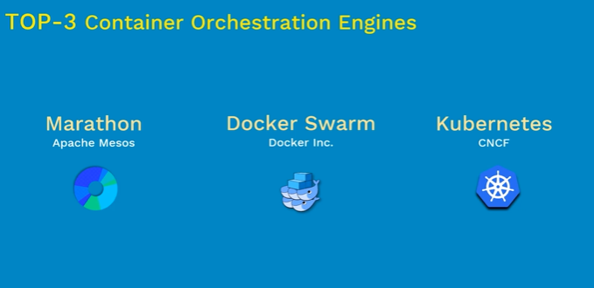

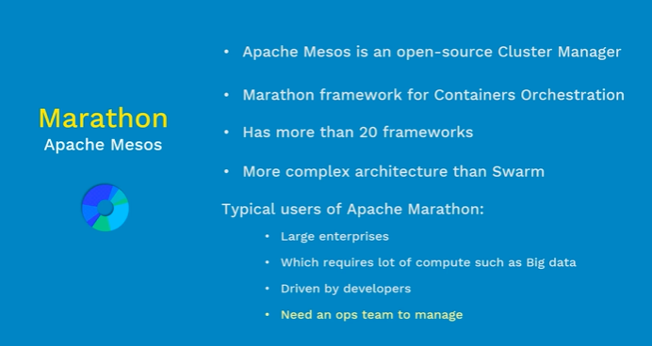

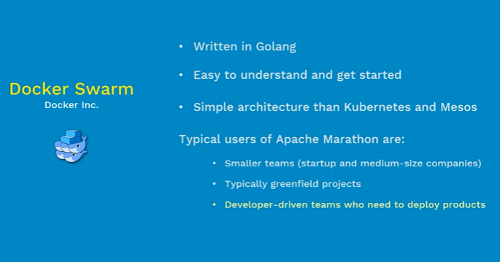

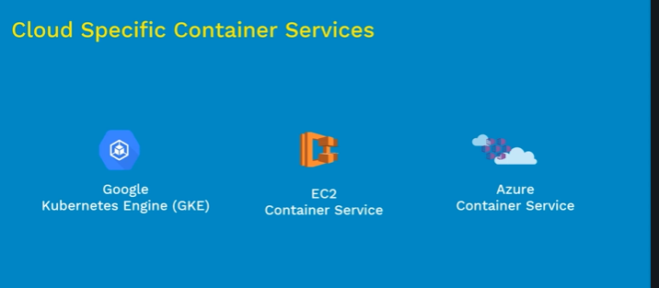

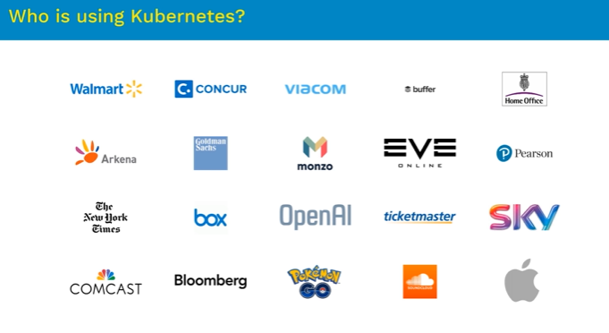

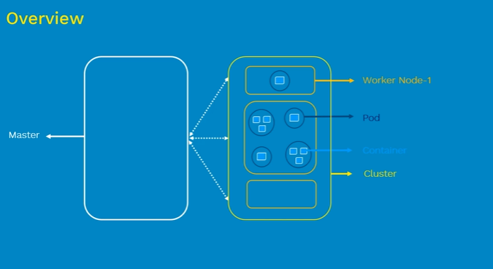

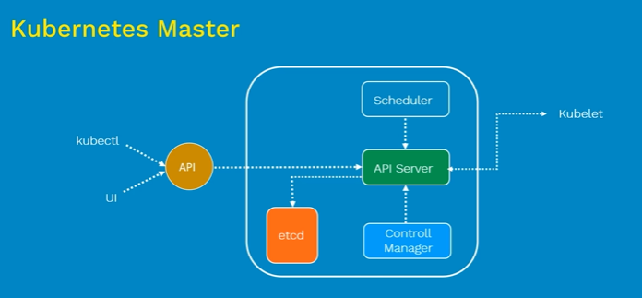

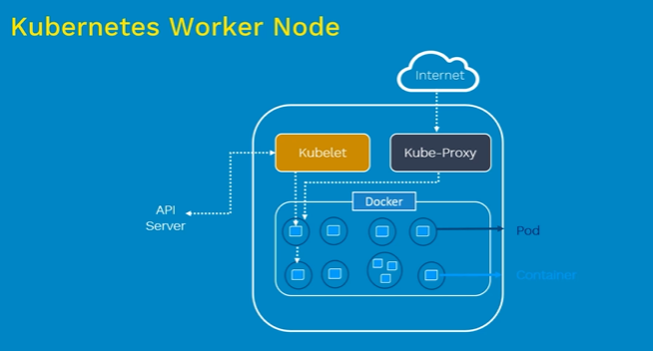

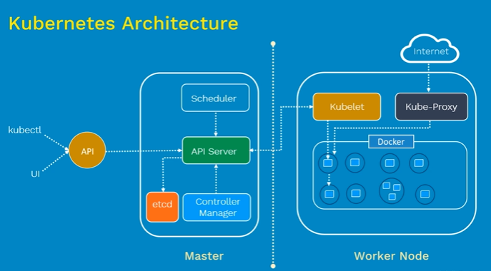

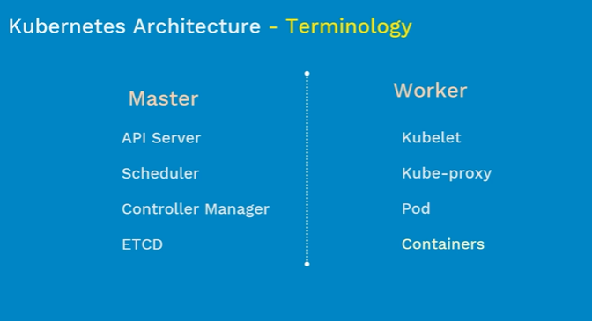

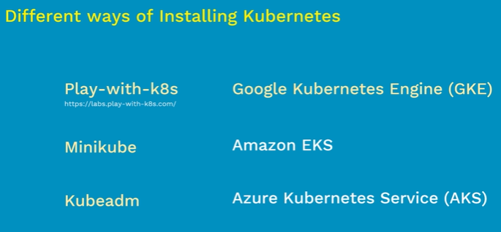

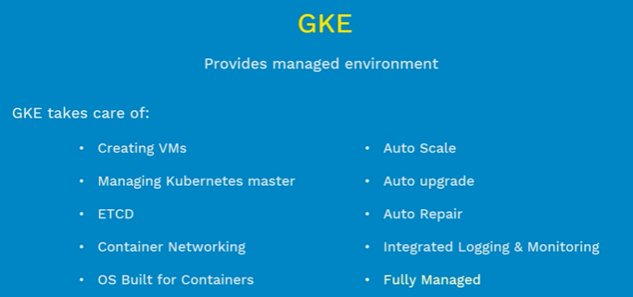

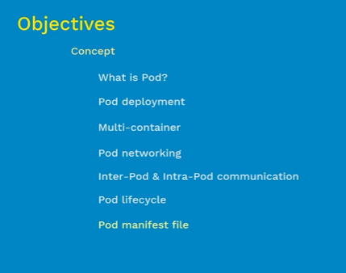

Typically we will one per pod. If we want to scale up kubernates will all more pods with same container. To scale down pods are deleted.

It is possible to have multiple containers per pod.

Mostly the extra containers are helper containers with are part of the pod which is used by the main container. They can refer each other as local host as they share the same host.

In this kind of scenario when main container starts helper container also start inside the pod and helper container dies when main container dies.

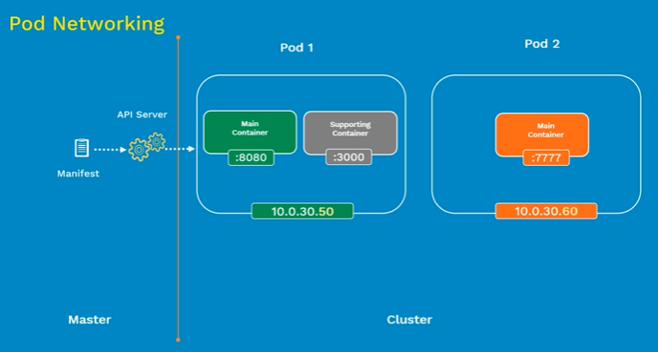

Every pod has a unique ip address.

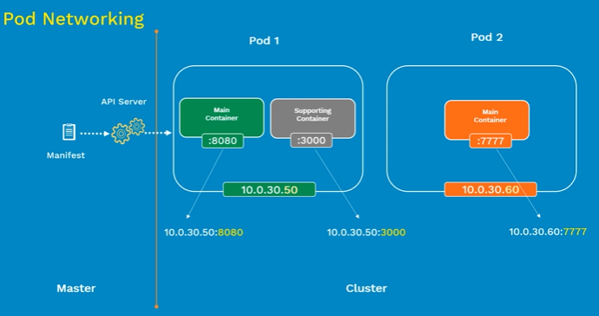

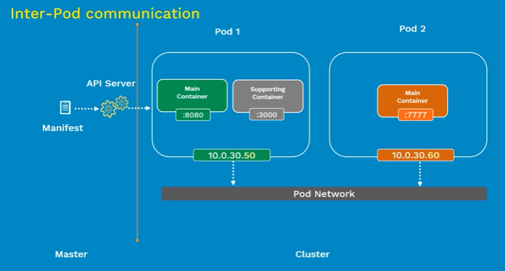

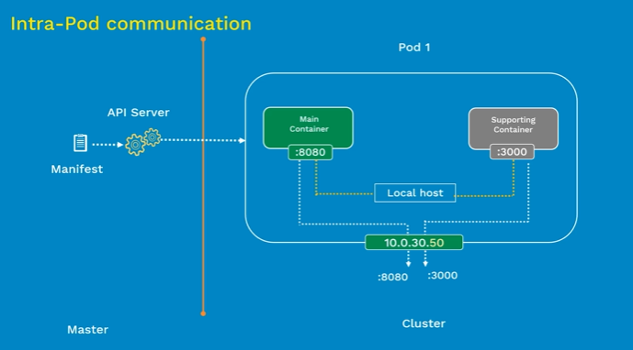

Containers running inside a pod can communicate to the outside world with the help of port. All containers need to expose different ports.

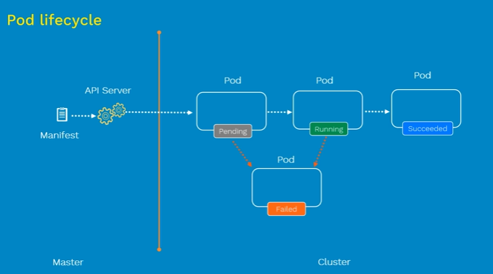

Pod manifest file written in Yml or json

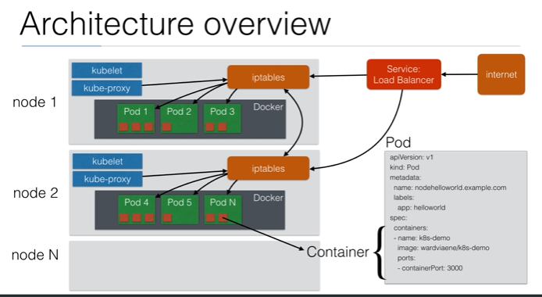

**Kubelet** is responsible for launching the pods. It connects to master node to get all information.

**KubeProxy** updates the **iptable** of the node with the information which pods are available for routing traffic.

All the internet traffic reaches the **Service Load balancer** then it gets routed to the **Iptable** and finally **iptable** routed the load to **Pods**.

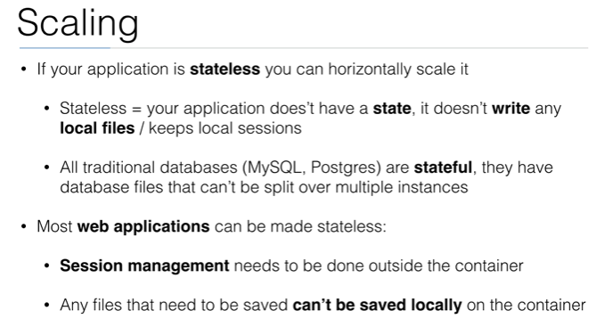

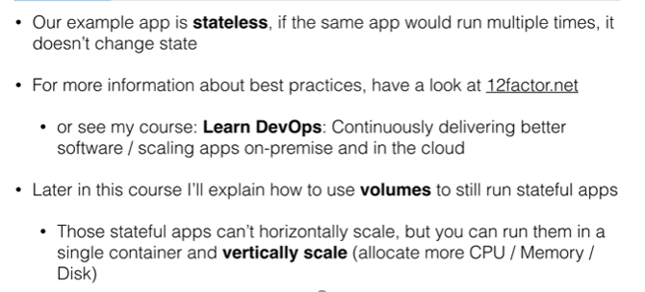

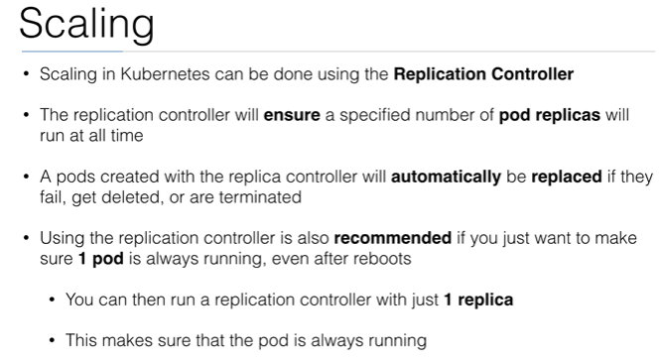

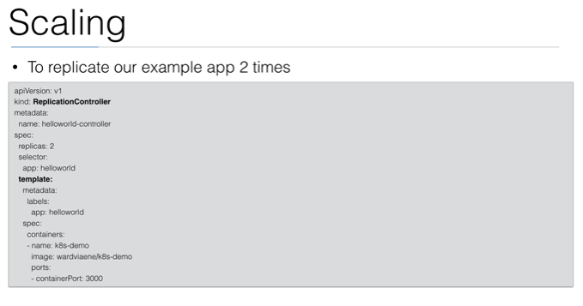

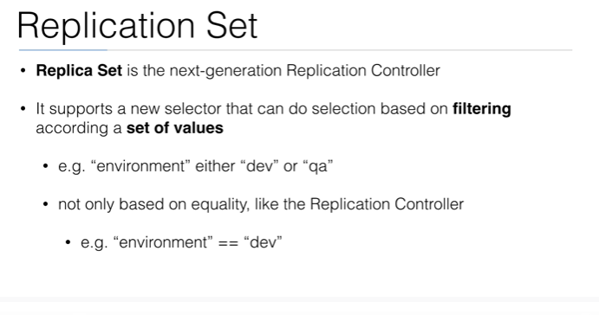

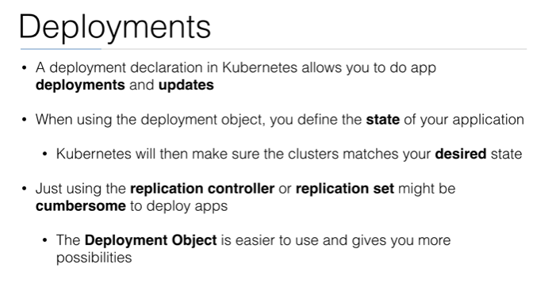

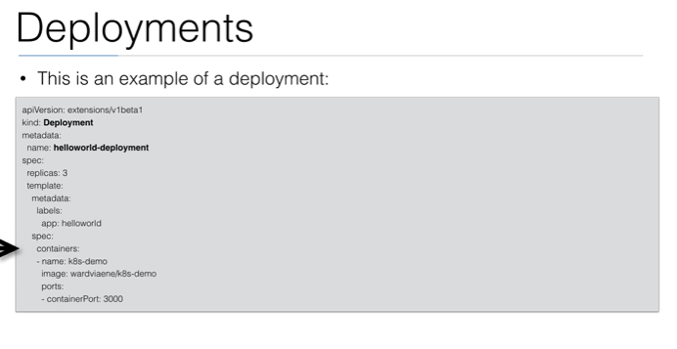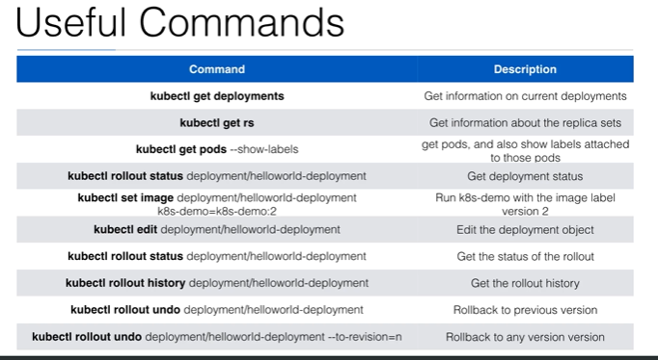

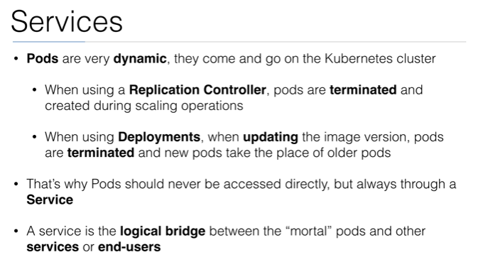

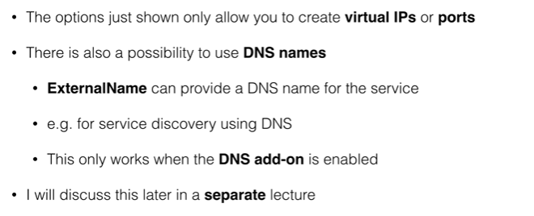

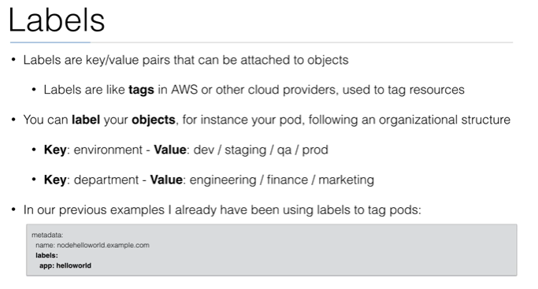

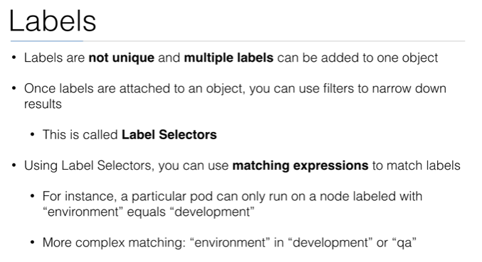

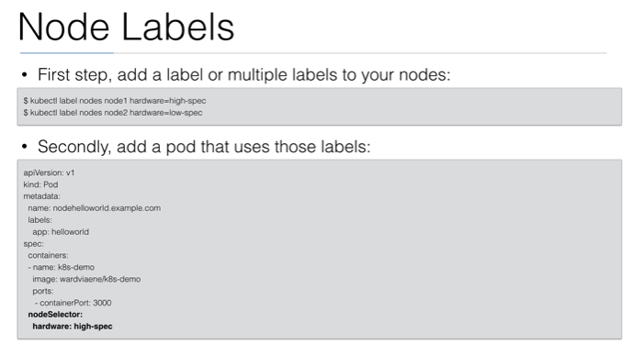

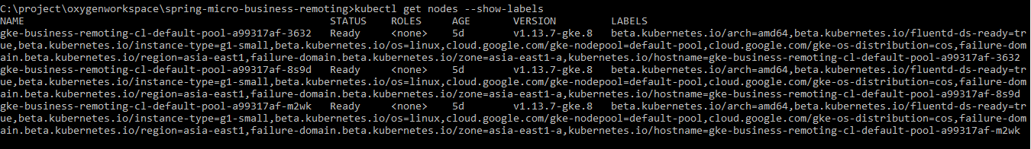

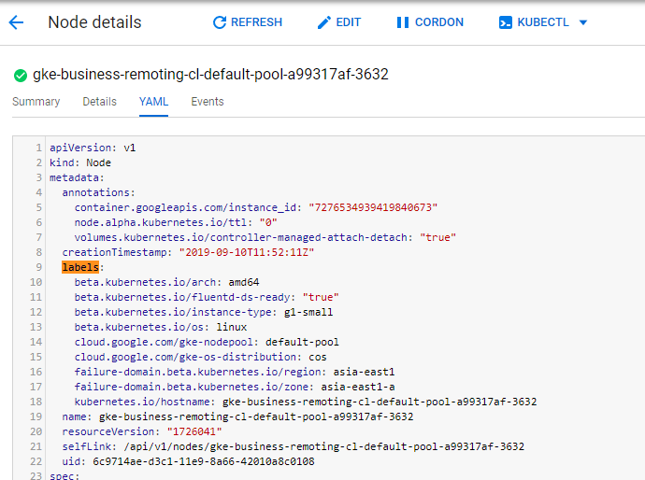

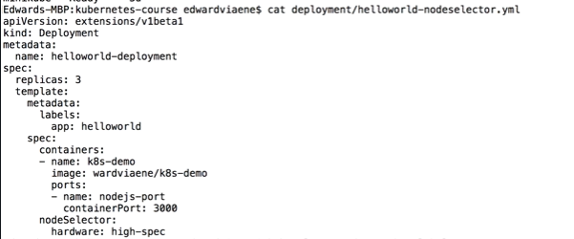

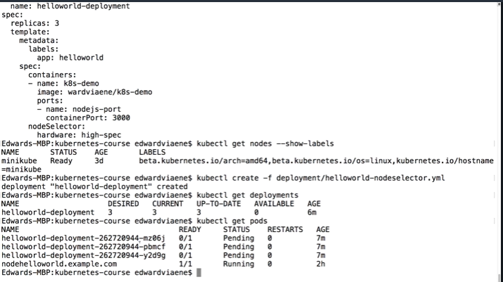

Kubectl describe pod one_of_podname

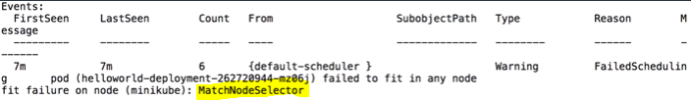

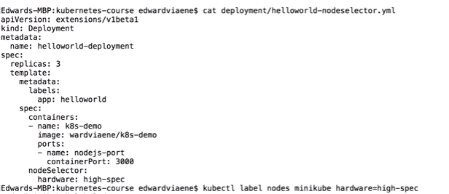

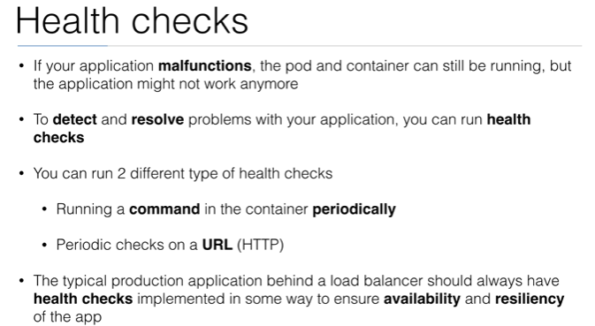

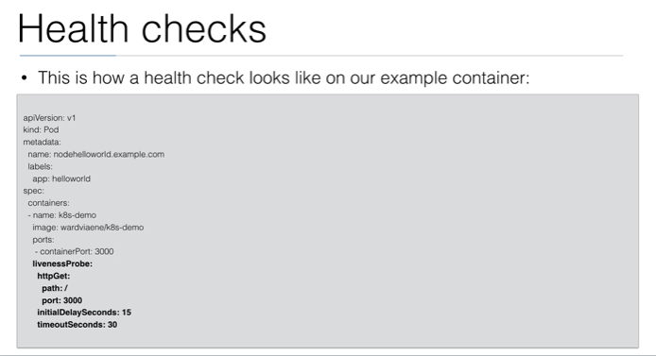

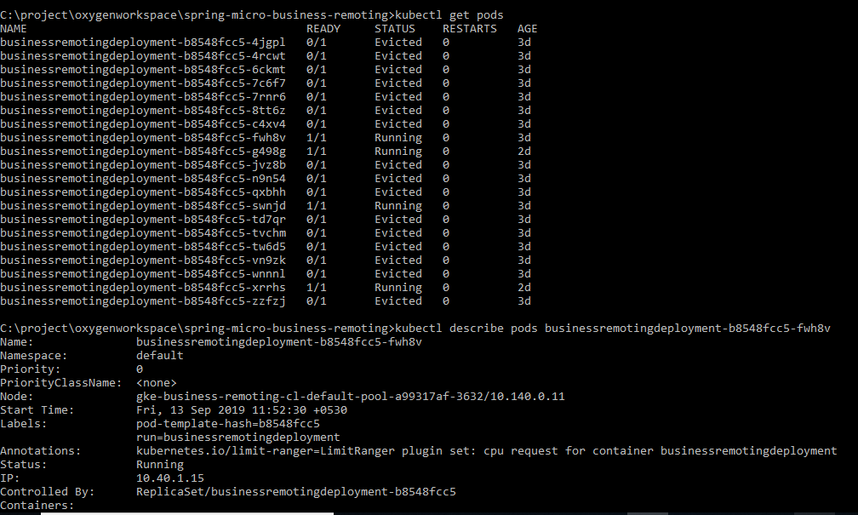

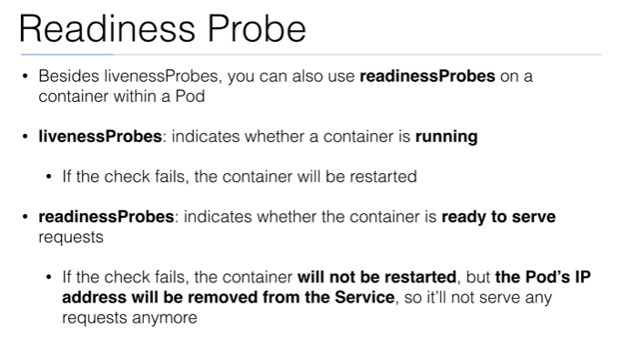

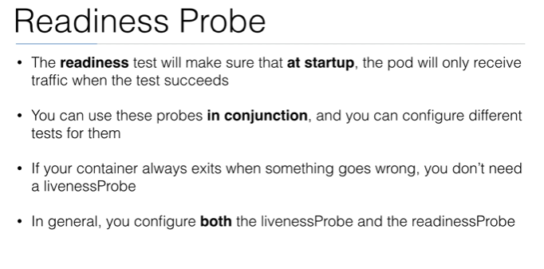

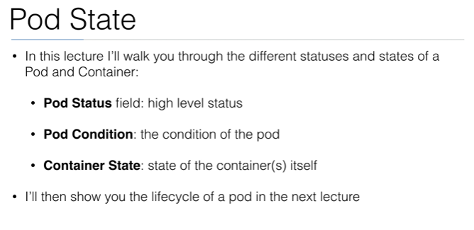

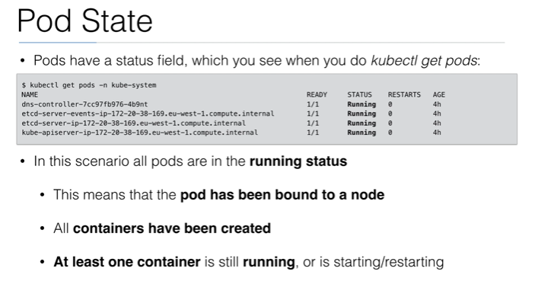

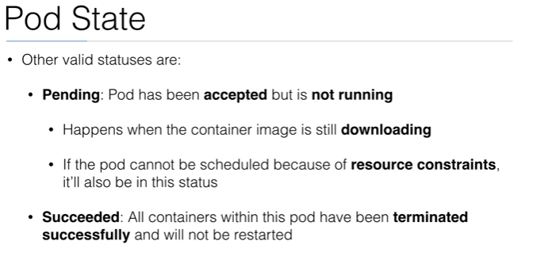

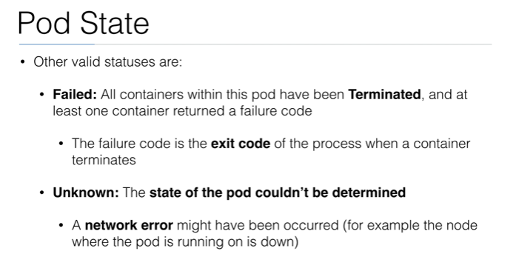

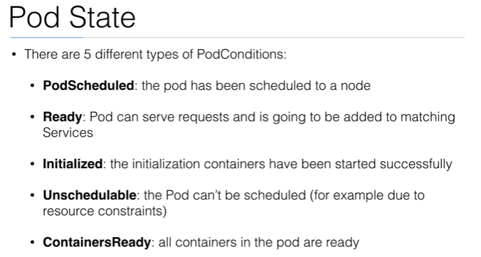

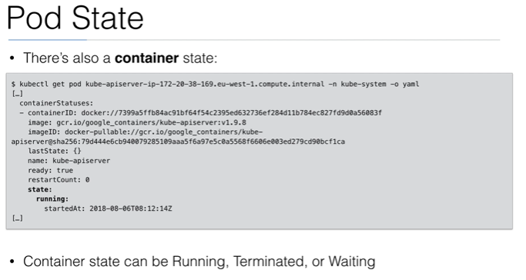

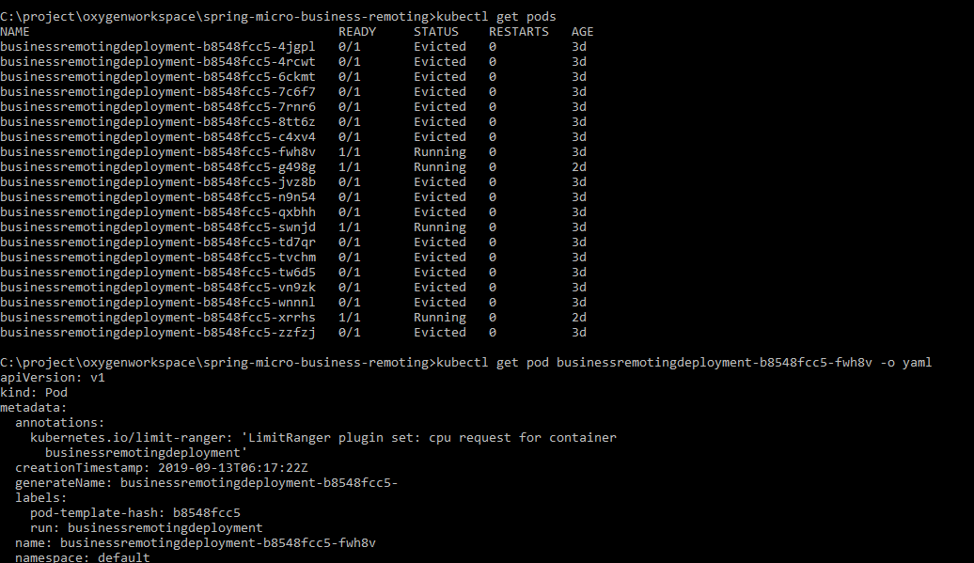

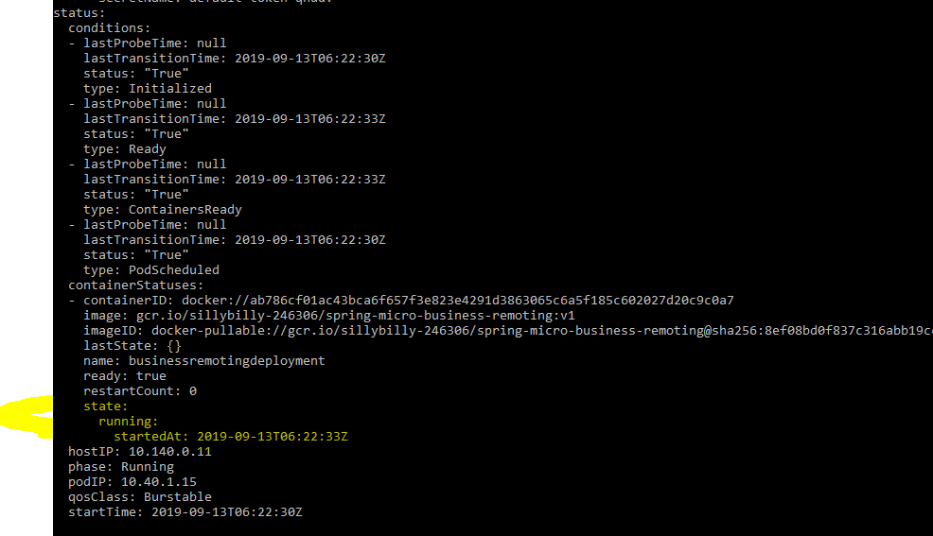

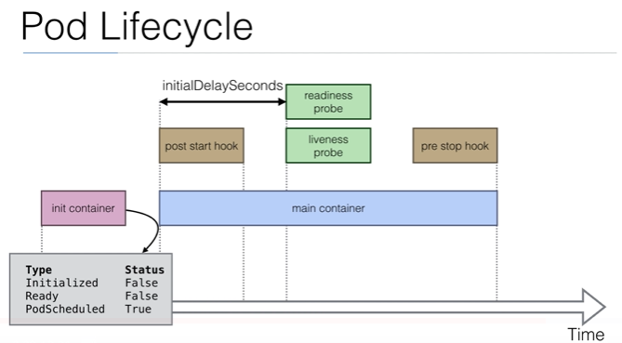

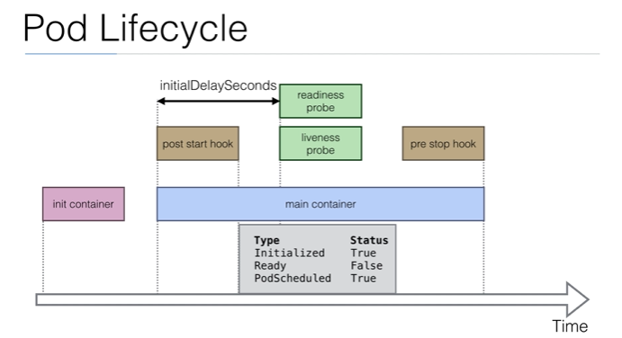

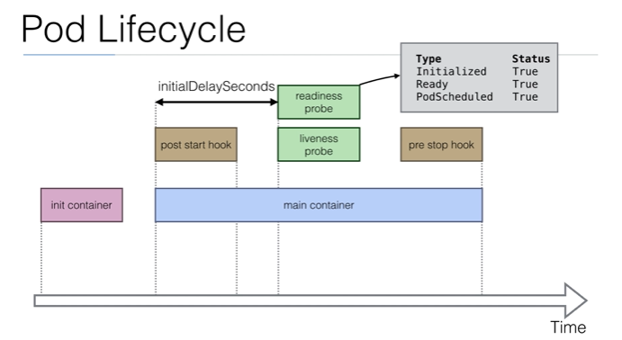

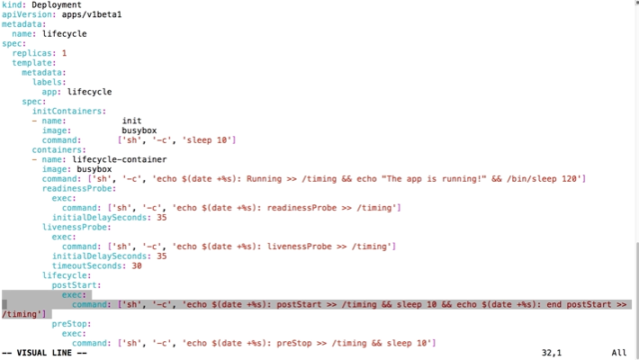

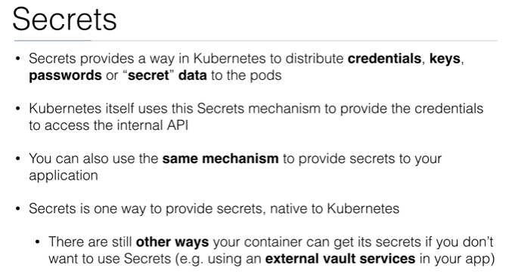

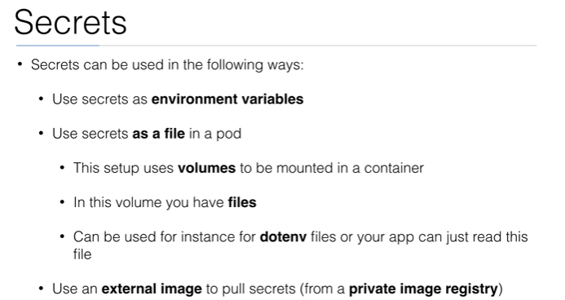

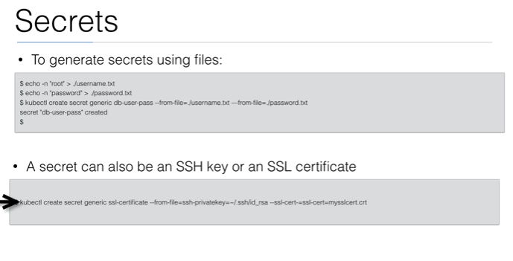

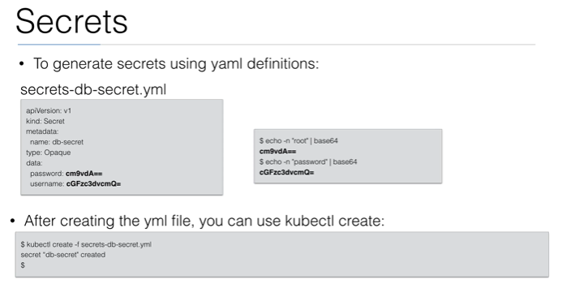

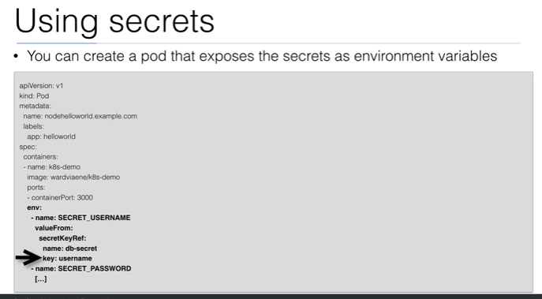

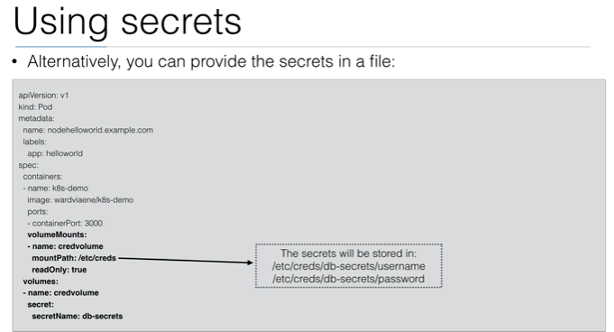



**Service Discovery**

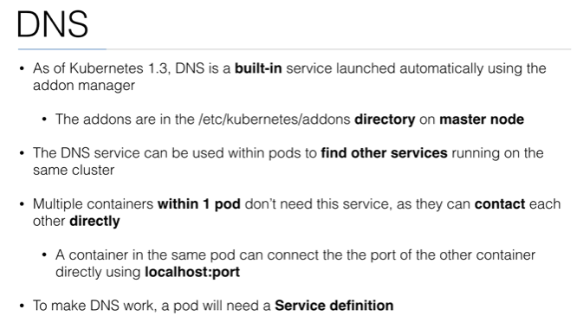

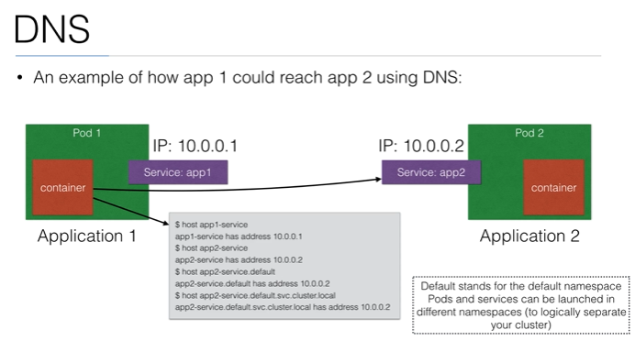

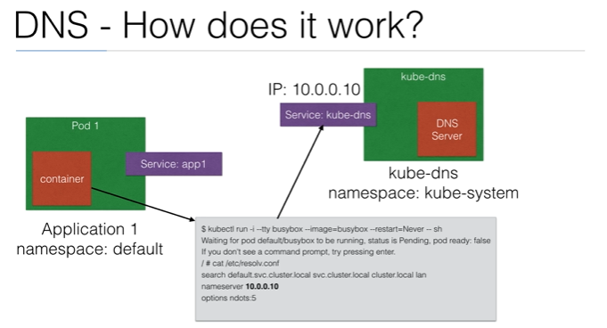

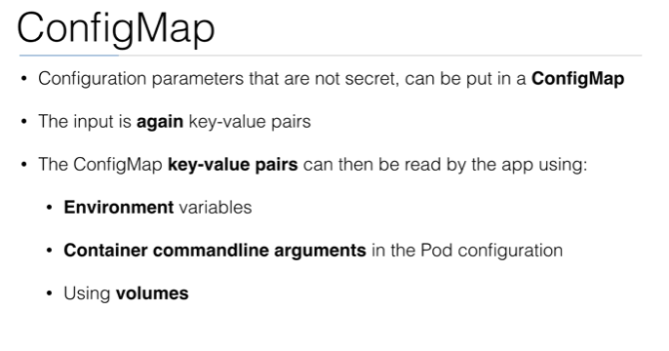

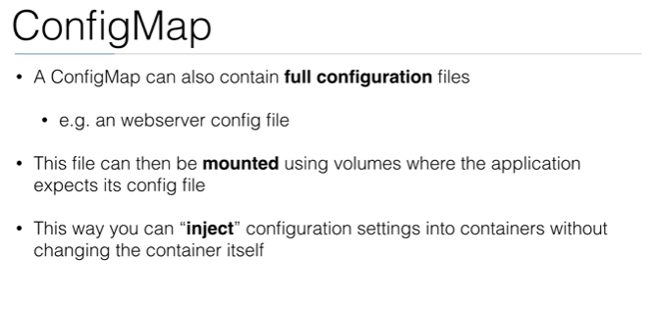

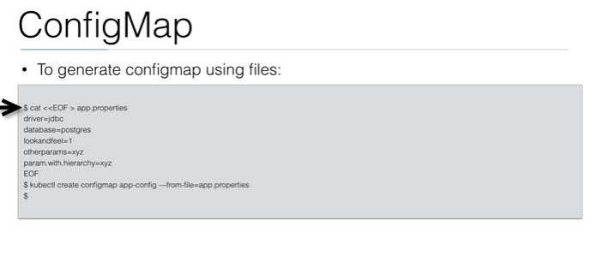

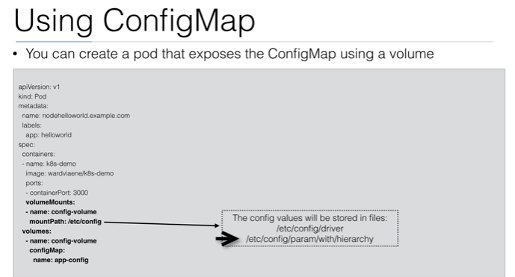

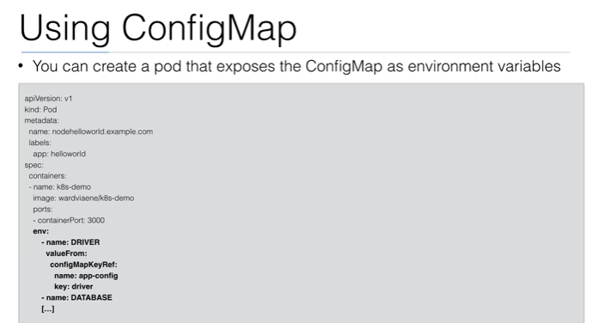

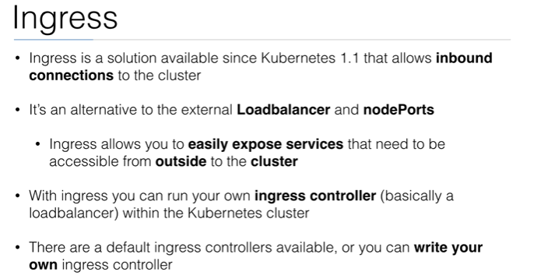

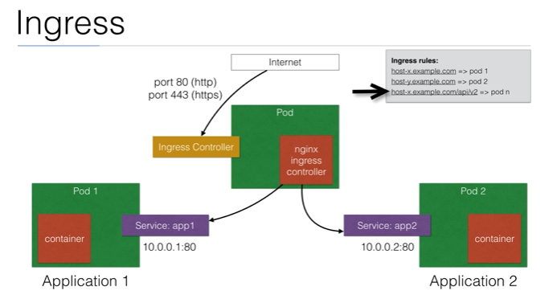

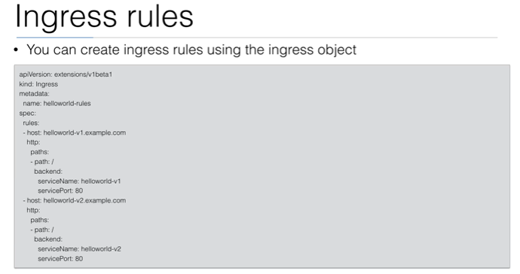

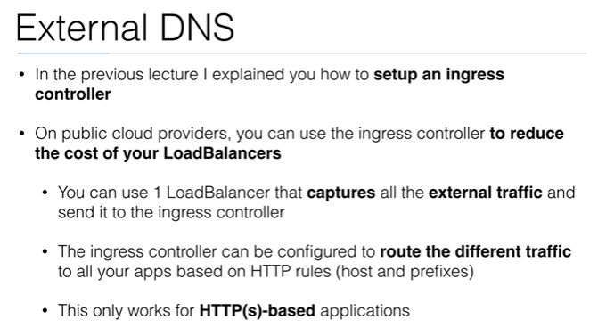

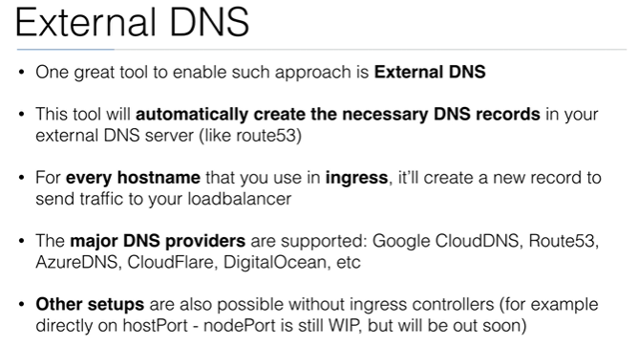

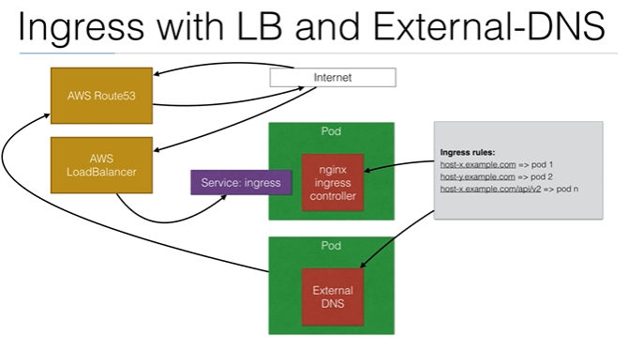

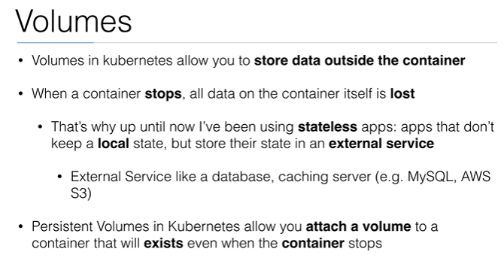

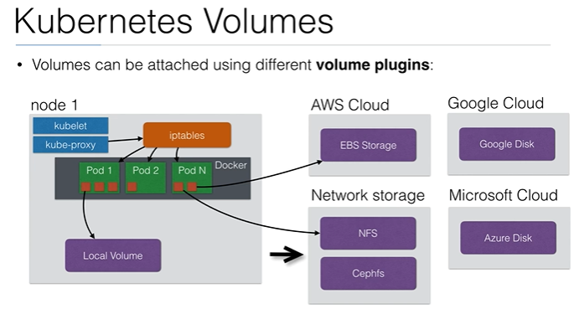

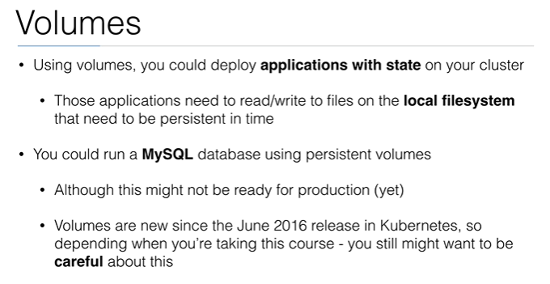

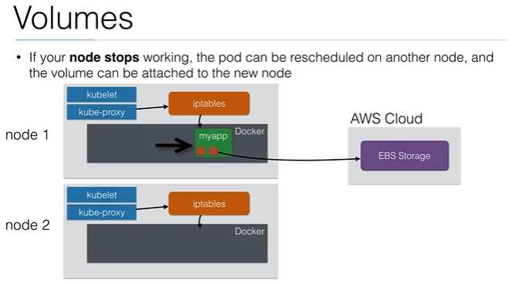

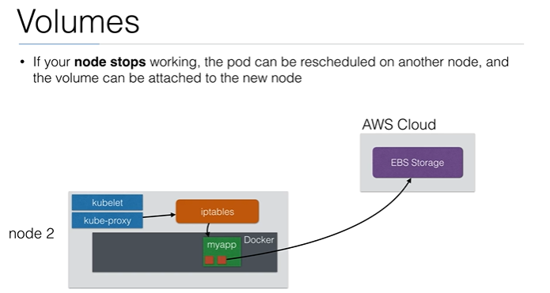

Nodes need to be in same availability zone.

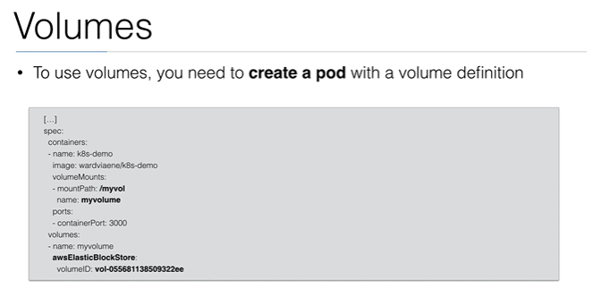

**Volumes In GKE**

Conceptually, a volume is a directory which is accessible to all of the containers in a Pod. The volume source declared in the Pod specification determines how the directory is created, the storage medium used, and the directory's initial contents. A Pod specifies what Volumes it contains and the path where containers mount the Volume.

Ephemeral Volume types have the same lifetimes as their enclosing Pods. These Volumes are created when the Pod is created, and they persist through container restarts. When the Pod terminates or is deleted its Volumes go with it.

**Types of volumes**

Volumes differ in their storage implementation and their initial contents. You can choose the Volume source that best fits your use case. Several common Volume sources are described below:

[**emptyDir**](https://kubernetes.io/docs/concepts/storage/volumes/#emptydir)

An ephemeral volume type that provides an empty directory that containers in the Pod can read and write from. When the Pod is removed from a node for any reason, the data in the emptyDir is deleted forever. emptyDirs are useful for scratch space and sharing data between multiple containers in a Pod.

[**configMap**](https://cloud.google.com/kubernetes-engine/docs/concepts/configmap)

Used to make configuration data accessible to applications. The files in a configMap Volume are specified by a ConfigMap resource.

[**secret**](https://cloud.google.com/kubernetes-engine/docs/concepts/secret)

Used to make sensitive data, such as passwords, OAuth tokens, and SSH keys, available to applications.

**Persistent Volumes**

Unlike [Volumes](https://cloud.google.com/kubernetes-engine/docs/concepts/volumes), the PersistentVolumes lifecycle is managed by Kubernetes. PersistentVolumes can be dynamically provisioned; the user does not have to manually create and delete the backing storage.

PersistentVolumes are cluster resources that exist independently of Pods. This means that the disk and data represented by a PersistentVolume continue to exist as the cluster changes and as Pods are deleted and recreated. PersistentVolume resources can be provisioned dynamically through PersistentVolumeClaims, or they can be explicitly created by a cluster administrator.

A **PersistentVolumeClaim** is a request for and claim to a PersistentVolume resource. PersistentVolumeClaim objects request a specific size, access mode, and StorageClass for the PersistentVolume. If a PersistentVolume that satisfies the request exists or can be provisioned, the PersistentVolumeClaim is bound to that PersistentVolume.

Pods use claims as Volumes. The cluster inspects the claim to find the bound Volume and mounts that Volume for the Pod.

Portability is another advantage of using PersistentVolumes and PersistentVolumeClaims. You can easily use the same [Pod specification](https://cloud.google.com/kubernetes-engine/docs/concepts/pod#pod_templates) across different clusters and environments because PersistentVolume is an interface to the actual backing storage.

apiVersion: v1  
kind: PersistentVolumeClaim  
metadata:  
  name: helloweb-disk  
spec:  
  accessModes:  
    - ReadWriteOnce  
  resources:  
    requests:  
      storage: 30Gi

kubectl apply -f pvc-demo.yaml

apiVersion: v1

kind: Pod

metadata:

name: mypod

spec:

containers:

- name: myfrontend

image: nginx

volumeMounts:

- mountPath: "/var/www/html"

name: mypd

volumes:

- name: mypd

persistentVolumeClaim:

claimName: myclaim

When you create this PersistentVolumeClaim with kubectl apply -f pvc-demo.yaml, Kubernetes dynamically creates a corresponding PersistentVolume object. Assuming that you haven't replaced the GKE default storage class, this PersistentVolume is backed by a new, empty Compute Engine persistent disk. You use this disk in a Pod by [using the claim as a volume](https://kubernetes.io/docs/concepts/storage/persistent-volumes/#claims-as-volumes).

When you delete this claim, the corresponding PersistentVolume object as well as the provisioned Compute Engine persistent disk are also deleted.

Should you want to prevent deletion of dynamically provisioned persistent disks, set the [reclaim policy](https://kubernetes.io/docs/concepts/storage/storage-classes/#reclaim-policy) of the PersistentVolume resource, or its StorageClass resource, to Retain. In this case, you are charged for the persistent disk for as long as it exists even if there is no PersistentVolumeClaim consuming it.

### **Reclaim Policy**

Persistent Volumes that are dynamically created by a storage class will have the reclaim policy specified in the reclaimPolicy field of the class, which can be either Delete or Retain. If no reclaimPolicy is specified when a StorageClass object is created, it will default to Delete.

Persistent Volumes that are created manually and managed via a storage class will have whatever reclaim policy they were assigned at creation.

apiVersion: storage.k8s.io/v1

kind: StorageClass

metadata:

name: standard

provisioner: kubernetes.io/aws-ebs

parameters:

type: gp2

reclaimPolicy: Retain

allowVolumeExpansion: true

mountOptions:

- debug

volumeBindingMode: Immediate

## Access Modes

PersistentVolumes support the following [access modes](https://kubernetes.io/docs/concepts/storage/persistent-volumes/#access-modes):

* **ReadWriteOnce:** The Volume can be mounted as read-write by a single node.
* **ReadOnlyMany:** The Volume can be mounted read-only by many nodes.
* **ReadWriteMany:** The Volume can be mounted as read-write by many nodes. PersistentVolumes that are backed by Compute Engine persistent disks don't support this access mode.

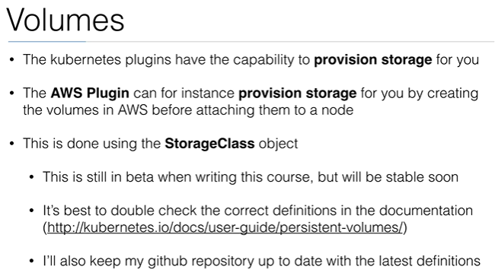

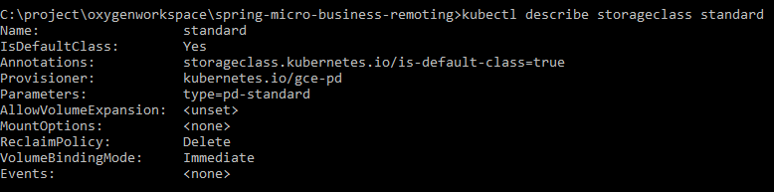

### **Type LoadBalancer**

On cloud providers which support external load balancers, setting the **type** field to **LoadBalancer** provisions a load balancer for your Service. The actual creation of the load balancer happens asynchronously, and information about the provisioned balancer is published in the Service’s **.status.loadBalancer** field. For example:

**apiVersion: v1**

**kind: Service**

**metadata:**

**name: my-service**

**spec:**

**selector:**

**app: MyApp**

**ports:**

**- protocol: TCP**

**port: 80**

**targetPort: 9376**

**clusterIP: 10.0.171.239**

**loadBalancerIP: 78.11.24.19**

**type: LoadBalancer**

**status:**

**loadBalancer:**

**ingress:**

**- ip: 146.148.47.155**

Traffic from the external load balancer is directed at the backend Pods. The cloud provider decides how it is load balanced.

Some cloud providers allow you to specify the **loadBalancerIP**. In those cases, the load-balancer is created with the user-specified **loadBalancerIP**. If the **loadBalancerIP** field is not specified, the loadBalancer is set up with an ephemeral IP address. If you specify a **loadBalancerIP** but your cloud provider does not support the feature, the **loadbalancerIP** field that you set is ignored.

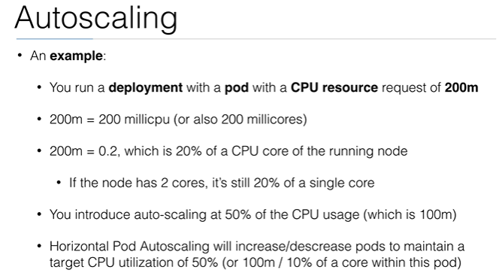

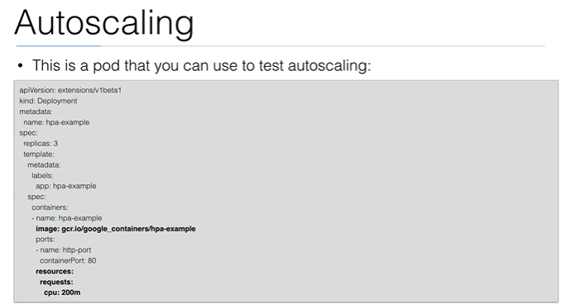

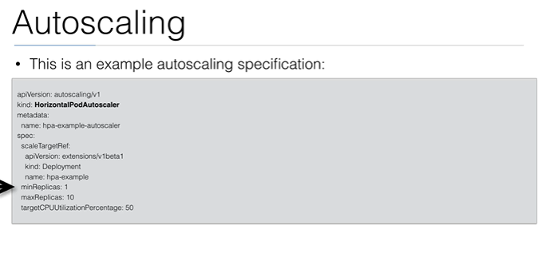

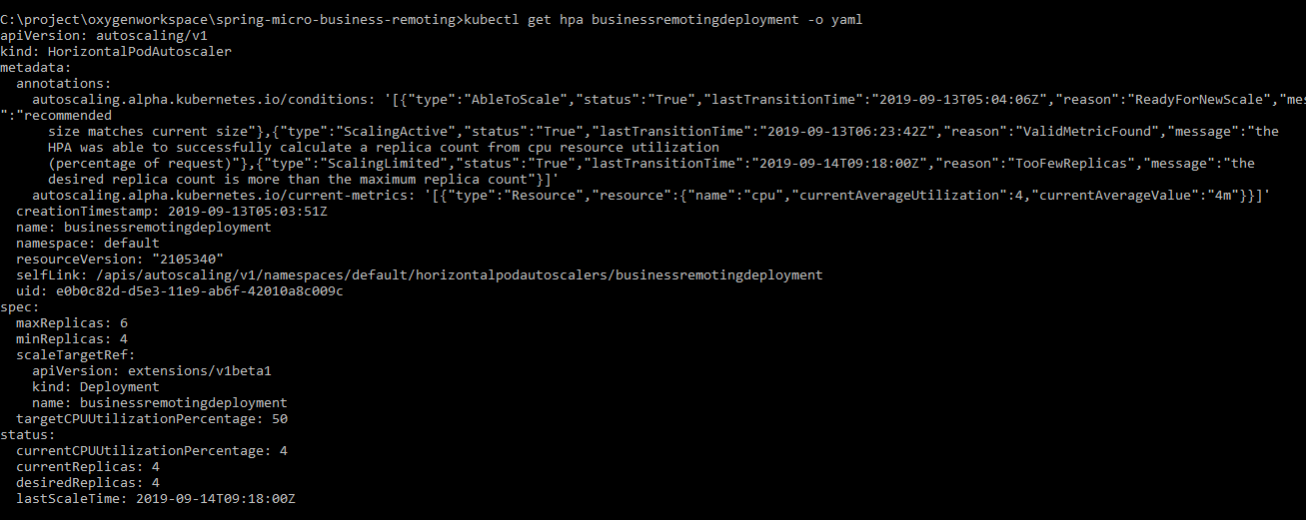

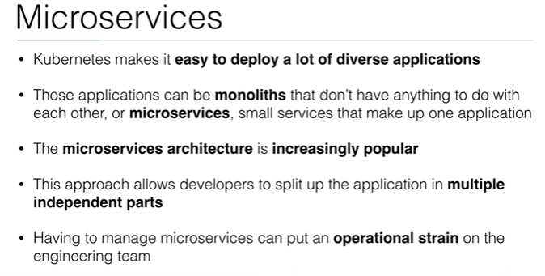

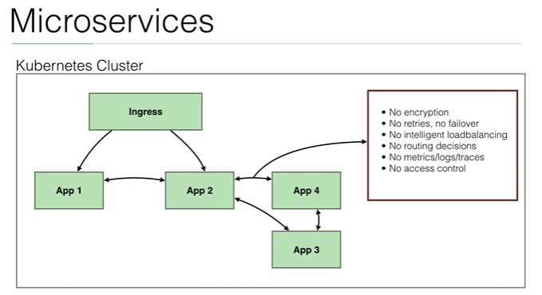

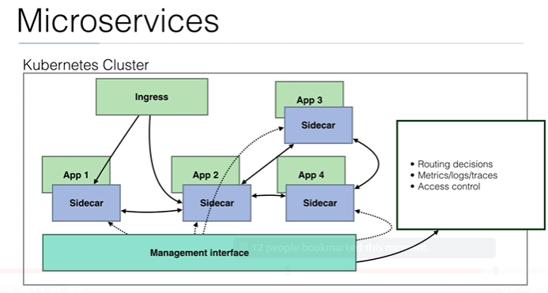

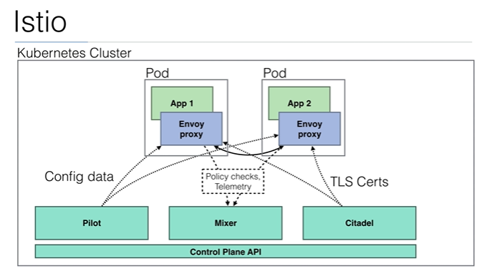

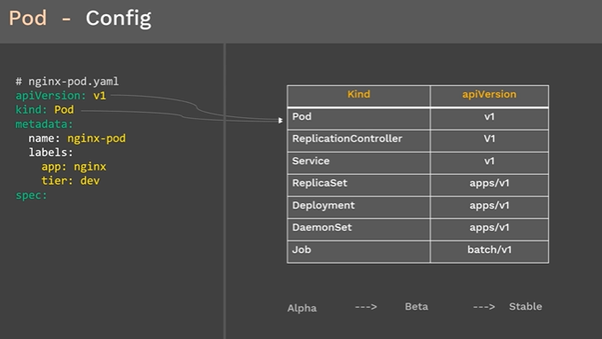

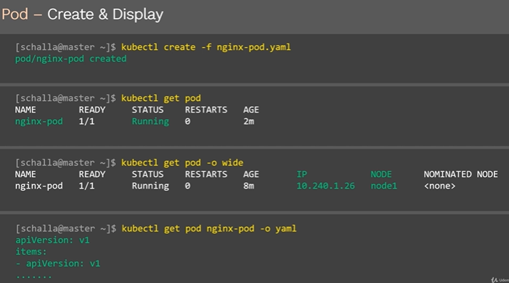

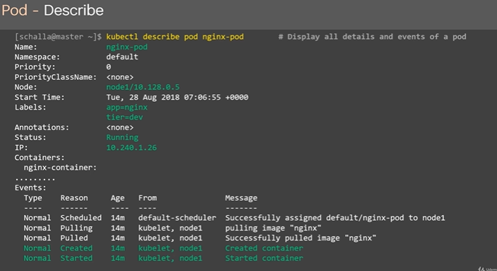

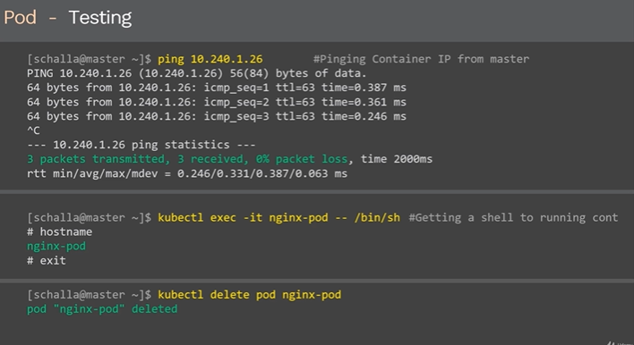

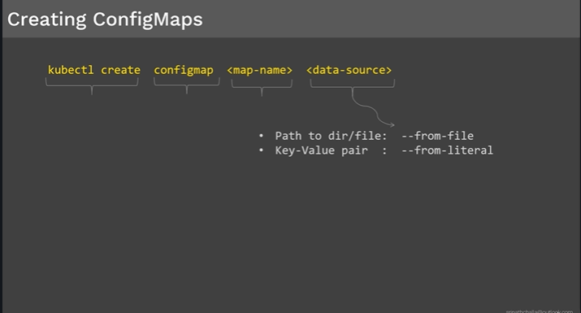

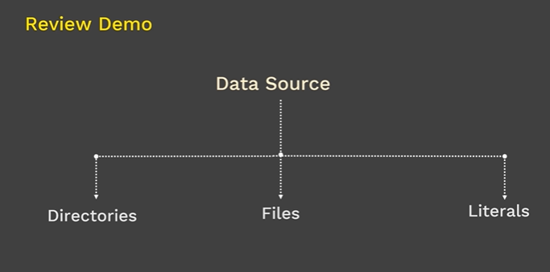

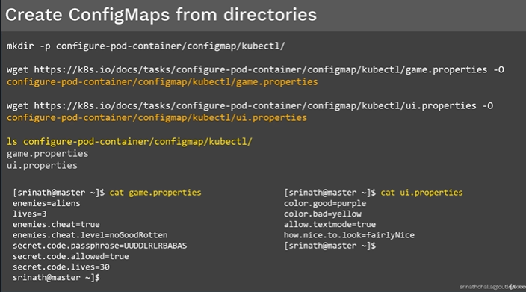

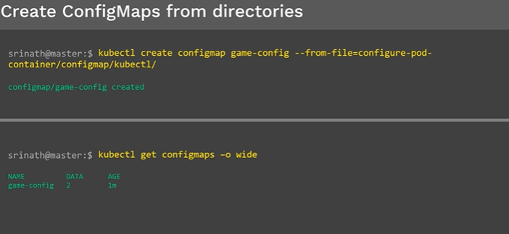

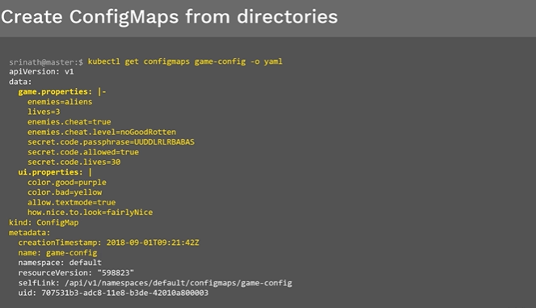

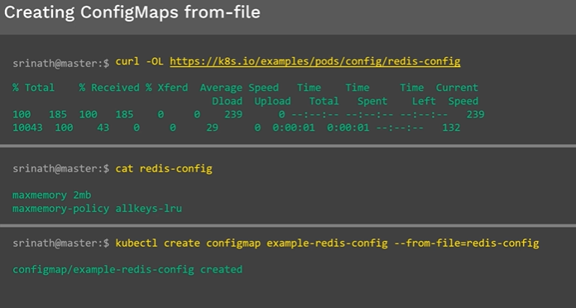

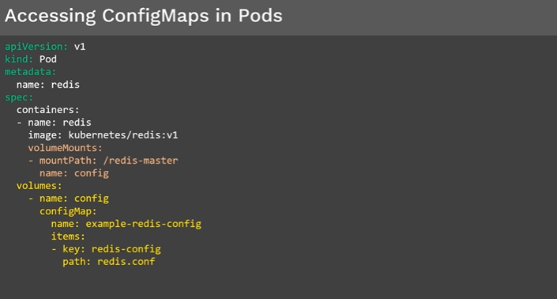

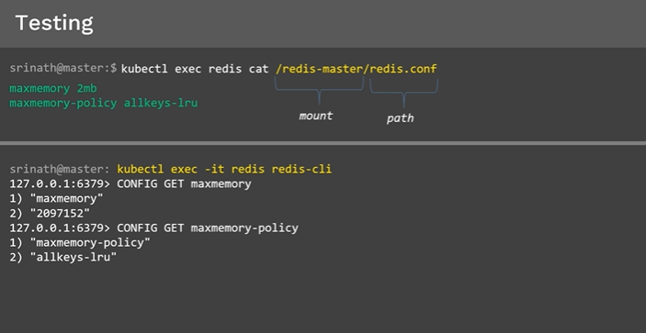

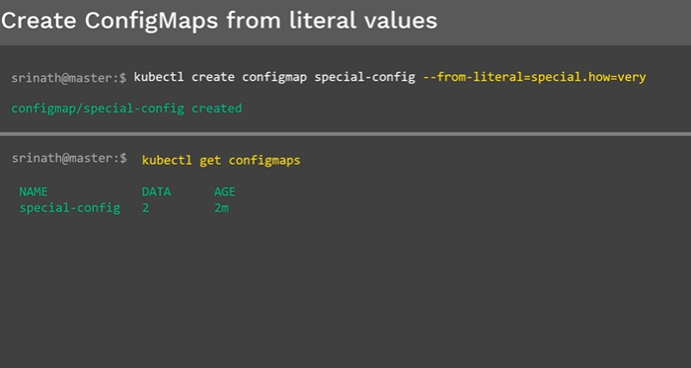

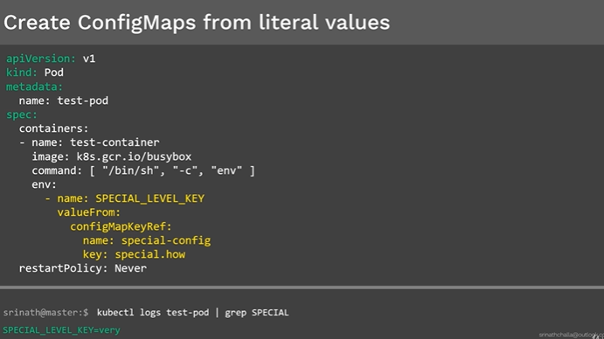

**\*\*\*\*\*\*\*\*\*\*\*\*\*\*\*\*\*\*\*\*\*\*\*\*\*\*\*\*\*\*\*\*\*\*\*\*\*\*\*\*\*\*\*\*\*\*\*\*\*\*\*\*\*\*\*\*\*\*\*\*\*\*\*\*\*\*\*\*\*\*\*\*\*\*\*\*\*\*\*\*\*\*\*\*\*\*\*\*\*\*\*\*\*\*\*\*\*\*\*\*\*\*\*\*\*\*\*\*\*\*\*\*\*\*\*\*\*\*\*\*\*\*\*\*\*\*\*\*\*\*\*\*\*\*\*\*\*\*\*\*\*\*\*\*\***

**.**

**. Demo: ConfigMaps | Srinath Challa**

**.**

**\*\*\*\*\*\*\*\*\*\*\*\*\*\*\*\*\*\*\*\*\*\*\*\*\*\*\*\*\*\*\*\*\*\*\*\*\*\*\*\*\*\*\*\*\*\*\*\*\*\*\*\*\*\*\*\*\*\*\*\*\*\*\*\*\*\*\*\*\*\*\*\*\*\*\*\*\*\*\*\*\*\*\*\*\*\*\*\*\*\*\*\*\*\*\*\*\*\*\*\*\*\*\*\*\*\*\*\*\*\*\*\*\*\*\*\*\*\*\*\*\*\*\*\*\*\*\*\*\*\*\*\*\*\*\*\*\*\*\*\*\*\*\*\*\***

**Overview:**

**---------**

**1. Creating Configmap from "multiple files" & Consuming it inside Pod from "volumes"**

**1a. Create Configmap "nginx-configmap-vol" from "multiple files"**

**1b. Consume "nginx-configmap-vol" configmap inside Pod from "volumes"**

**1c. Create | Display | Validate**

**2. Creating Configmap from "literal values" & Consuming it inside Pod from "environment variables"**

**2a. Create configmap “redis-configmap-env” from "literal values"**

**2b. Consume “redis-configmap-env” configmap inside pod from “Environment Variables” inside pod**

**2c. Create | Display | Validate**

**3. Cleanup**

**3a. Delete configmaps**

**3b. Delete pods**

**3c. Validate**

**\*\*\*\*\*\*\*\*\*\*\*\*\*\*\*\*\*\*\*\*\*\*\*\*\*\*\*\*\*\*\*\*\*\*\*\*\*\*\*\*\*\*\*\*\*\*\*\*\*\*\*\*\*\*\*\*\*\*\*\*\*\*\*\*\*\*\*\*\*\*\*\*\*\*\*\*\*\*\*\*\*\*\*\*\*\*\*\*\*\*\*\*\*\*\*\*\*\*\*\*\*\*\*\*\*\*\*\*\*\*\*\*\*\*\*\*\*\*\*\*\*\*\*\*\*\*\*\*\*\*\*\*\*\*\*\*\*\*\*\*\*\*\*\*\***

**1. Creating Configmap from "multiple files" & Consuming it inside Pod from "volumes"**

**1a. Create Configmap "nginx-configmap-vol" from "multiple files":**

**------------------------------------------------------------------**

**echo -n 'Non-sensitive data inside file-1' > file-1.txt**

**echo -n 'Non-sensitive data inside file-2' > file-2.txt**

**kubectl create configmap nginx-configmap-vol --from-file=file-1.txt --from-file=file-2.txt**

**# rm -f file-1 file-2**

**kubectl get configmaps**

**kubectl describe configmaps nginx-configmap-vol**

**==========================================================**

**1b. Consume above "nginx-configmap-vol" configmap inside Pod from "volumes"**

**---------------------------------------------------------------------------**

**#nginx-pod-configmap-vol.yaml**

**apiVersion: v1**

**kind: Pod**

**metadata:**

**name: nginx-pod-configmap-vol**

**spec:**

**containers:**

**- name: nginx-container**

**image: nginx**

**volumeMounts:**

**- name: test-vol**

**mountPath: "/etc/non-sensitive-data"**

**readOnly: true**

**volumes:**

**- name: test-vol**

**configMap:**

**name: nginx-configmap-vol**

**items:**

**- key: file-1.txt**

**path: file-a.txt**

**- key: file-2.txt**

**path: file-b.txt**

**==========================================================**

**1c. Create | Display | Validate:**

**--------------------------------**

**# Create**

**kubectl create -f nginx-pod-configmap-vol.yaml**

**# Display**

**kubectl get po**

**kubectl get configmaps**

**kubectl describe pod nginx-pod-configmap-vol**

**# Validate from "inside" the pod**

**kubectl exec nginx-pod-configmap-vol -it /bin/sh**

**cd /etc/non-sensitive-data**

**ls**

**cat Non-sensitive data inside file-1.txt**

**cat password.txt**

**exit**

**(OR)**

**# Validate from "outside" the pod**

**kubectl exec nginx-pod-configmap-vol ls /etc/non-sensitive-data**

**kubectl exec nginx-pod-configmap-vol cat /etc/non-sensitive-data/file-a.txt**

**kubectl exec nginx-pod-configmap-vol cat /etc/non-sensitive-data/file-b.txt**

**\*\*\*\*\*\*\*\*\*\*\*\*\*\*\*\*\*\*\*\*\*\*\*\*\*\*\*\*\*\*\*\*\*\*\*\*\*\*\*\*\*\*\*\*\*\*\*\*\*\*\*\*\*\*\*\*\*\*\*\*\*\*\*\*\*\*\*\*\*\*\*\*\*\*\*\*\*\*\*\*\*\*\*\*\*\*\*\*\*\*\*\*\*\*\*\*\*\*\*\*\*\*\*\*\*\*\*\*\*\*\*\*\*\*\*\*\*\*\*\*\*\*\*\*\*\*\*\*\*\*\*\*\*\*\*\*\*\*\*\*\*\*\*\*\***

**2. Creating Configmap from "literal values" & Consuming it inside Pod from "environment variables"**

**2a. Create configmap “redis-configmap-env” from "literal values"**

**-----------------------------------------------------------------**

**kubectl create configmap redis-configmap-env --from-literal=file.1=file.a --from-literal=file.2=file.b**

**kubectl get configmap**

**kubectl describe configmap redis-configmap-env**

**===============================================================================**

**2b. Consume “redis-configmap-env” configmap inside pod from “Environment Variables” inside pod**

**-----------------------------------------------------------------------------------------------**

**# redis-pod-configmap-env.yaml**

**apiVersion: v1**

**kind: Pod**

**metadata:**

**name: redis-pod-configmap-env**

**spec:**

**containers:**

**- name: redis-container**

**image: redis**

**env:**

**- name: FILE_1**

**valueFrom:**

**configMapKeyRef:**

**name: redis-configmap-env**

**key: file.1**

**- name: FILE_2**

**valueFrom:**

**configMapKeyRef:**

**name: redis-configmap-env**

**key: file.2**

**restartPolicy: Never**

**===============================================================================**

**2c. Create | Display | Validate:**

**# Create**

**kubectl create -f redis-pod-configmap-env.yaml**

**# Display**

**kubectl get pods**

**kubectl get configmaps**

**kubectl describe pod redis-pod-configmap-env**

**# Validate from "inside" the pod**

**kubectl exec redis-pod-configmap-env -it /bin/sh**

**env | grep FILE**

**exit**

**(OR)**

**# Validate from "outside" the pod**

**kubectl exec redis-pod-configmap-env env | grep FILE**

**\*\*\*\*\*\*\*\*\*\*\*\*\*\*\*\*\*\*\*\*\*\*\*\*\*\*\*\*\*\*\*\*\*\*\*\*\*\*\*\*\*\*\*\*\*\*\*\*\*\*\*\*\*\*\*\*\*\*\*\*\*\*\*\*\*\*\*\*\*\*\*\*\*\*\*\*\*\*\*\*\*\*\*\*\*\*\*\*\*\*\*\*\*\*\*\*\*\*\*\*\*\*\*\*\*\*\*\*\*\*\*\*\*\*\*\*\*\*\*\*\*\*\*\*\*\*\*\*\*\*\*\*\*\*\*\*\*\*\*\*\*\*\*\*\***

**3. Cleanup**

**# Delete configmaps**

**kubectl delete configmaps nginx-configmap-vol redis-configmap-env**

**# Delete pods**

**kubectl delete pods nginx-pod-configmap-vol redis-pod-configmap-env**

**# Validate**

**kubectl get pods**

**kubectl get configmaps**

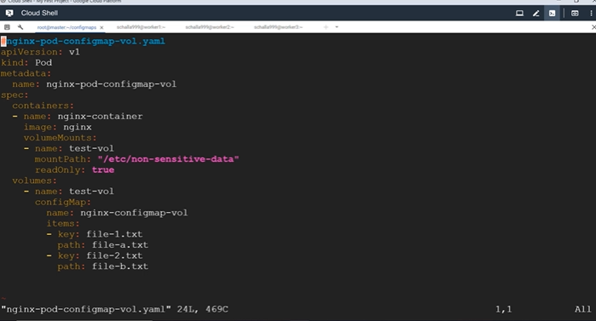

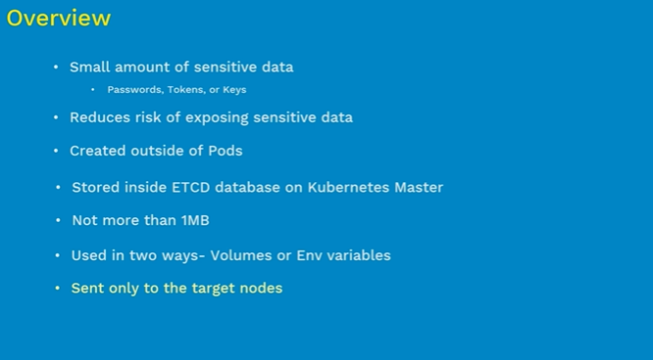

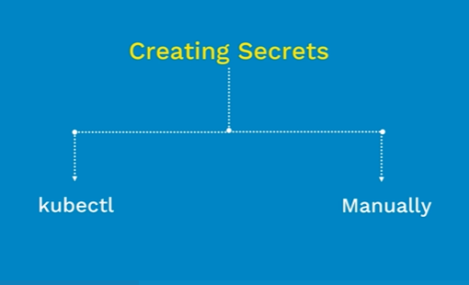

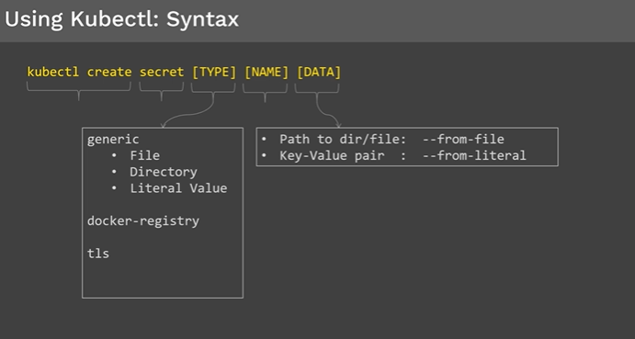

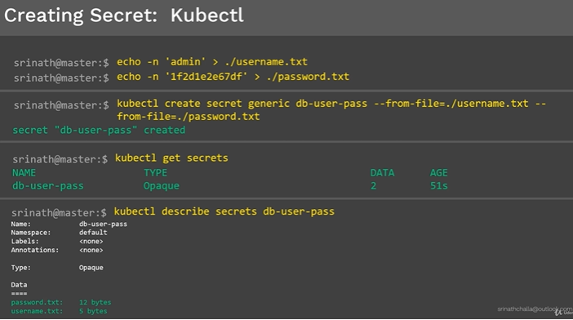

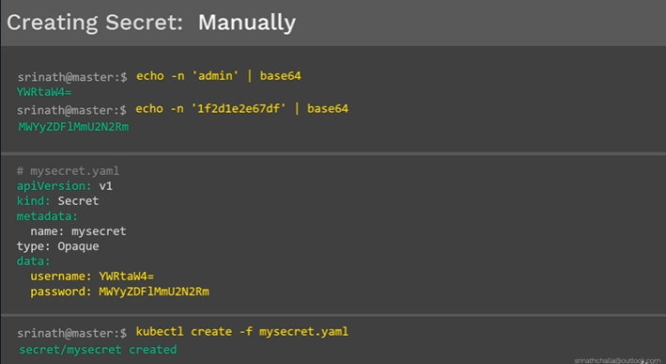

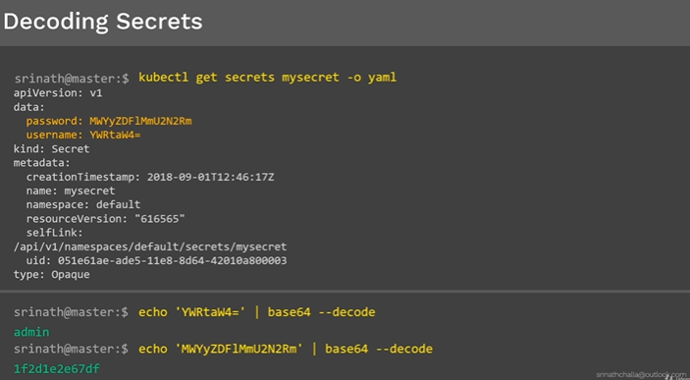

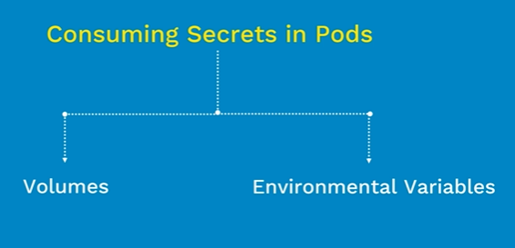

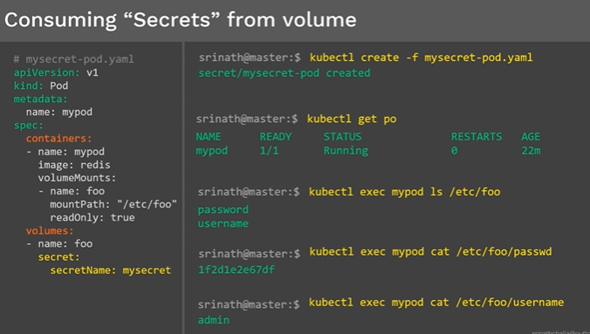

## 

## 

## 

## 

## Difference between rs (replication controller) and rs (replica set) equality based selectors and set based selectors

## 

## 

## 

## 

## 

## 

## 

## 

## 

## 

## 

## Both equality based selectors and set based selectors can be applied to Replicaset manifest yml file.

## 

## 

## 

## 

## 

## 

## 

## 

## 

## 

## 

## To deploy pod we do not need to have different manifest files like pod or replica set. All those things can be done using singe deployment manifest file which includes pod definition and Replicaset definition also.

## 

## 

## 

## 

## 

## 

## 

## 

## 

## 

## 

## 

## Demon set

## 

## 

## 

## 

## 

## 

## 

## 

## 

## By deleting the demon set it will make sure it deletes all the pods it created.

## 

## 

## 

## 

## 

## 

## 

## 

## 

## 

## 

## 

## 

## 

## 

## If nodeport not assigned kubernaties will automatically assign a node port in the range.